**Project Design Phase**

|  |  |
| --- | --- |
| **Date** | 26-05-2025 |
| **Team ID** | LTVIP2025TMID34023 |
| **Project Name** | Citizen Ai – Intelligent Citizen  Engagement Platform |
| **Maximum Marks** | 2 Marks |

**Proposed Solution Template:**

**Project team shall fill the following information in the proposed solution template.**

**S.No**

**Parameter**

**Description**

**1**

**Problem Statement**

**)**

**(**

**Problem to be solved**

**Governments often**

**struggle to provide**

**efficient, real**

**-**

**time, and**

**personalized engagement**

**with citizens regarding**

**services, policies, and civic**

**concerns. Citizens face**

**delays, lack of clarity, and**

**generic responses, leading**

**to low**

**level of satisfaction**

**and trust in**

**governance.**

**2**

**Idea / Solution description**

**Citizen AI is an intelligent**

**engagement platform**

**leveraging IBM Granite**

**models, Flask, and IBM**

**Watson to deliver real**

**-**

**time, AI**

**-**

**driven responses**

**to citizen queries. It**

**integrates NLP, sentiment**

**analysis, and analytics**

**dashboards to enhance**

**public interactio**

**n,**

**transparency, and**

**government**

**responsiveness.**

**3**

**Novelty / Uniqueness**

**Combines real**

**-**

**time**

**conversational AI,**

**sentiment analytics, and a**

**personalized response**

**system within a**

**government context.**

**Integrates IBM Granite**

**and Watson technologies**

**with a user**

**-**

**friendly Flask**

|  |  |  |
| --- | --- | --- |
|  |  | **front end to deliver smart, contextual, and scalable citizen engagement.** |
| **4** | **Social Impact / Customer**  **Satisfaction** | **Empowers citizens with instant, accessible information and support. Improves transparency, fosters public trust, and enables data-driven governance. Enhances service delivery and policy responsiveness through actionable insights from real-time citizen feedback.** |
| **5** | **Business Model (Revenue**  **Model)** | **B2G SaaS model offers government agencies a subscription-based platform with tiered pricing for additional modules (e.g., sentiment analytics, personalized NLU models, and dashboard**  **customizations). Potential expansion into smart city and civic engagement ecosystems.** |
| **6** | **Scalability of the Solution** | **Designed with a cloudnative architecture using Flask and IBM services, Citizen AI can scale across municipalities, state agencies, and national platforms. Modular design allows for easy integration with existing government digital infrastructure and APIs.** |

**Citizen Ai: Project Report**

# 1. INTRODUCTION

## 1.1 Project Overview

**Citizen AI is a next-generation, AI-powered platform aimed at transforming how governments engage with their citizens. By harnessing the power of IBM Granite models, IBM Watson, and a Flask-based web framework, Citizen AI enables realtime, intelligent, and personalized interactions between citizens and government services.**

**The platform is designed to address key challenges in public service delivery, such as inefficient communication, lack of transparency, and limited insight into citizen sentiment. With a focus on accessibility, responsiveness, and data-driven governance, Citizen AI empowers both citizens and policymakers.**

## 1.2 Purpose

The purpose of Citizen AI is to enhance the way governments interact with citizens by providing a smart, real-time, and personalized engagement platform. It aims to bridge the communication gap between public institutions and the people they serve by leveraging artificial intelligence technologies.

**2. IDEATION PHASE**

## 2.1 Problem Statement

Government agencies often face challenges in effectively engaging with citizens, responding to queries in a timely manner, and understanding public sentiment regarding services and policies. Citizens, on the other hand, struggle with accessing accurate information, experience delays in communication, and feel disconnected from decisionmaking processes. There is a need for a smart, AI-based platform that can enhance citizen-government interaction through real-time responses, sentiment analysis, and actionable insights.

## 2.2 Empathy Map Canvas

 Says**:**

* "Why is it so hard to get information about public services?"
* "I wish I could get faster responses from government departments."

 Thinks**:**

* "Does the government even consider our feedback?"
* "Are they doing anything about the complaints people post online?"

 Does**:**

* Searches websites and social media for updates on government services.
* Submits complaints or queries through portals and waits for long periods.

 Feels**:**

* Frustrated, unheard, disconnected, and skeptical of government transparency.

## 2.3 Brainstorming

Key ideas discussed:

 Real-time conversational AI assistant for citizen interaction.

 AI-driven sentiment analysis of citizen feedback.

 Personalized and contextual responses using advanced NLP models (e.g., IBM Granite).

 Dynamic dashboards for visualizing citizen sentiment, query trends, and service ratings.

 Integration with existing government APIs and digital services.

# 3. REQUIREMENT ANALYSIS

## 3.1 Customer Journey Map

A citizen accesses the Citizen AI platform via a secure login or guest session. They ask a question about public service (e.g., "How do I apply for a voter ID?"). The AI assistant responds instantly with accurate, contextual information using IBM Granite models. The platform captures feedback or sentiment from the user. This data is processed and reflected on a government dashboard in real-time, helping officials monitor engagement and respond to issues proactively.

**3.2 Solution Requirement**

# Functional Requirements

* Citizen and admin login system
* AI-powered conversational assistant
* Sentiment analysis engine
* Feedback submission and tagging
* Real-time analytics dashboard
* Admin panel for monitoring service issues and trends

# Non-Functional Requirements

* High availability and responsiveness (real-time interaction)
* Scalable cloud-native infrastructure
* Secure communication (HTTPS, OAuth2)
* Multilingual support
* Modular design for integration with various government APIs
* Compliance with data protection and digital governance standards

## 3.3 Data Flow Diagram

**Basic Interaction Flow**

[Citizen]

↓

[Login / Submit Query / Feedback]

↓

[Flask Backend + API Gateway]

↓

+----------------------------------+

| 1. Validate Input |

| 2. NLP Request to IBM Granite |

| 3. Store Interaction in DB |

+----------------------------------+

↓

[Processed Output Sent to Frontend]

↓

[Displayed to Citizen]

# Feedback and Sentiment Processing Flow

[Citizen Feedback]

↓

[Flask Backend]

↓

[Sentiment Analysis Module (Watson / Custom NLP)]

↓

[Result Stored in Database]

↓

[Dashboard Visualized for Admins]

# Dashboard Flow

↓

[Login to Dashboard]

↓

[Backend Aggregates Sentiment / Queries]

↓

[Real-Time Visualization with Charts & Tables]

↓

[Insight-Driven Decision Making]

## 3.4 Technology Stack

|  |  |
| --- | --- |
| **Layer** | **Technology** |
| **Frontend** | Html,tailwind css |
| **Backend** | Flask (Python) – RESTful APIs for routing and business logic |
| **AI/NLP** | IBM Granite for conversational AI, Watson NLP for sentiment analysis |
| **Database** | MongoDB Atlas – stores citizen queries, sentiment data, usage logs |
| **Authentication** | Auth0 or Clerk.dev – secure citizen and admin login/auth management |
| **Dashboard Tools** | Chart.js or D3.js – for real-time interactive analytics |
| **Cloud Hosting** | IBM Cloud, Railway, or Render – supports scalable and  CI/CD-enabled deployment |
| **Monitoring &**  **Logging** | Prometheus + Grafana or LogRocket – for observing app health and interaction logs |

# 4. PROJECT DESIGN

## 4.1 Problem-Solution Fit

**Citizens often face delays, confusion, and poor accessibility when engaging with government services. Government officials lack real-time feedback and insight into public sentiment, which limits their ability to make timely, informed decisions.**

**Citizen AI bridges this gap by offering citizens instant, AI-driven responses to queries and enabling government agencies to monitor public feedback through real-time dashboards. The platform automates routine interactions, improves public satisfaction, and enables data-driven governance.**

## 4.2 Proposed Solution

**A smart, scalable citizen engagement platform that:**

* **Provides real-time conversational support to citizens using an AI assistant powered by IBM Granite.**
* **Analyzes sentiment from user feedback to track satisfaction and flag potential issues.**
* **Displays interactive analytics dashboards to government officials for decision support.**
* **Offers a unified portal for both citizens and administrators, enhancing transparency and civic interaction.**

## 4.3 Solution Architecture

The architecture of Citizen AI is designed for performance, modularity, and scalability.

It includes the following components:

* **Frontend:**
  + - Built with **React.js or Next.js** for dynamic rendering.
    - Provides role-based routing for **citizens** an.
    - Responsive UI for desktop and mobile access.
* **Backend API:**
  + Developed using **Flask (Python)** for handling logic, routing, and communication with services.
  + Exposes endpoints for:
    - * Citizen query handling
      * Sentiment analysis
      * Dashboard data aggregation ▪ Authentication & access control
* **AI Integration:**
  + Uses **IBM Granite models** for natural language understanding and contextual, human-like responses.
  + Incorporates **IBM Watson NLP** for analyzing citizen sentiment (positive, neutral, negative).
* **Database & Storage:**
  + **MongoDB Atlas** or a **vector database** (like Pinecone or Weaviate) for storing:
    - * Citizen queries and responses
      * Sentiment data
      * Interaction logs and metadata
* **Cloud Hosting & Scalability:**
  + Deployed on platforms like **IBM Cloud**, **Railway**, or **Render** with CI/CD support.
  + Cloud-native architecture enables horizontal scaling across regions or agencies.

# 5. PROJECT PLANNING & SCHEDULING

**5.1 Project Planning**

# Week Tasks

**Week** Requirement analysis and testing IBM Granite model integration for **1** conversational responses.

**Week** Backend API development using Flask and integration with MongoDB **2** Atlas for storing queries, feedback, and sentiment data.

**Week** Development of the dynamic admin dashboard with role-based **3** authentication for citizens and government officials.

**Week** Performance testing of AI assistant and dashboards; final deployment on **4** a cloud platform (e.g., IBM Cloud, Railway).

# 6. FUNCTIONAL AND PERFORMANCE TESTING

## 6.1 Performance Testing

**Comprehensive functional and performance testing was conducted across the platform’s core features:**

* **Conversational AI endpoints were tested for response time and accuracy under varying user loads.**
* **The sentiment analysis module was validated with different tones and query types to ensure reliable classification.**
* **Login and role-based access were tested to confirm secure and responsive user handling.**
* **Dashboard rendering was evaluated for scalability, especially during peak interaction periods.**

# 7. RESULTS

## 7.1 Output Screenshots

The output visuals of **Citizen AI** demonstrate its core functionality and intuitive design:

* **Citizen Login Interface** – A simple and secure screen for users to begin interacting with government services.
* **Conversational Chat UI** – Shows real-time AI-generated responses to user queries on services like tax filing, ID application, or complaint tracking.
* **Sentiment Visualization Dashboard** – Displays categorized citizen sentiment over time (positive, neutral, negative).
* **Issue Analytics Panel** – Highlights the most common public concerns and their geographic or departmental distribution.
* **Admin Panel** – For monitoring usage statistics, sentiment trends, and feedback summaries.

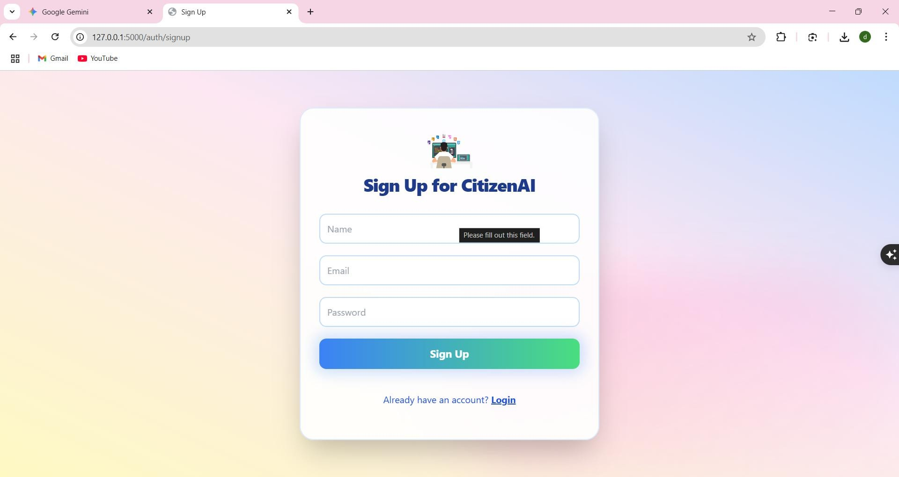

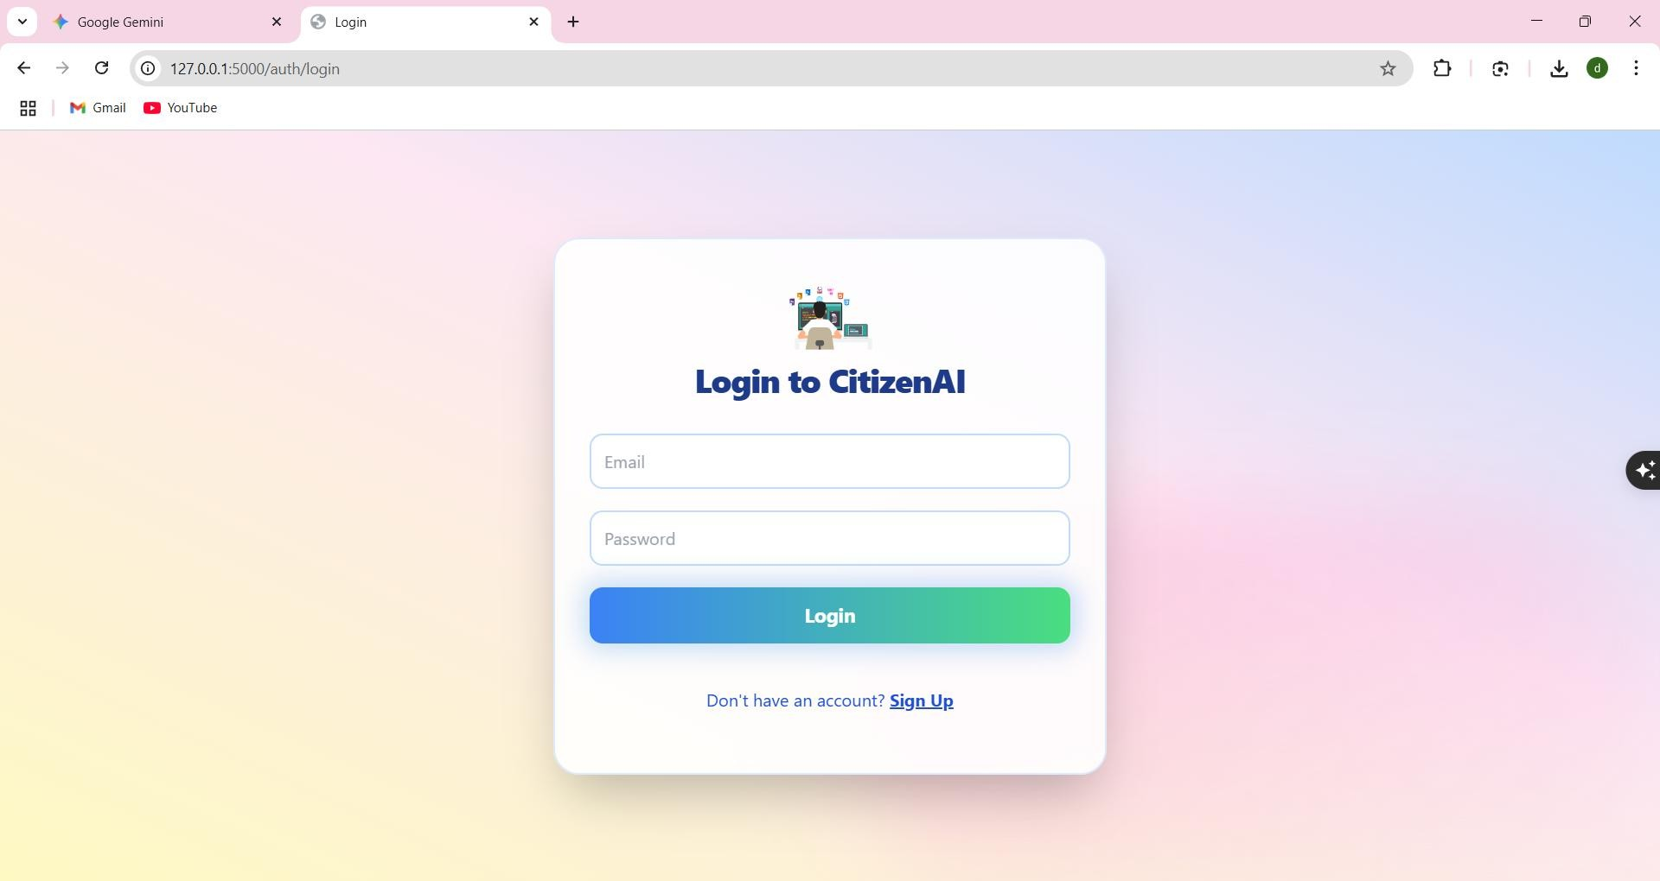

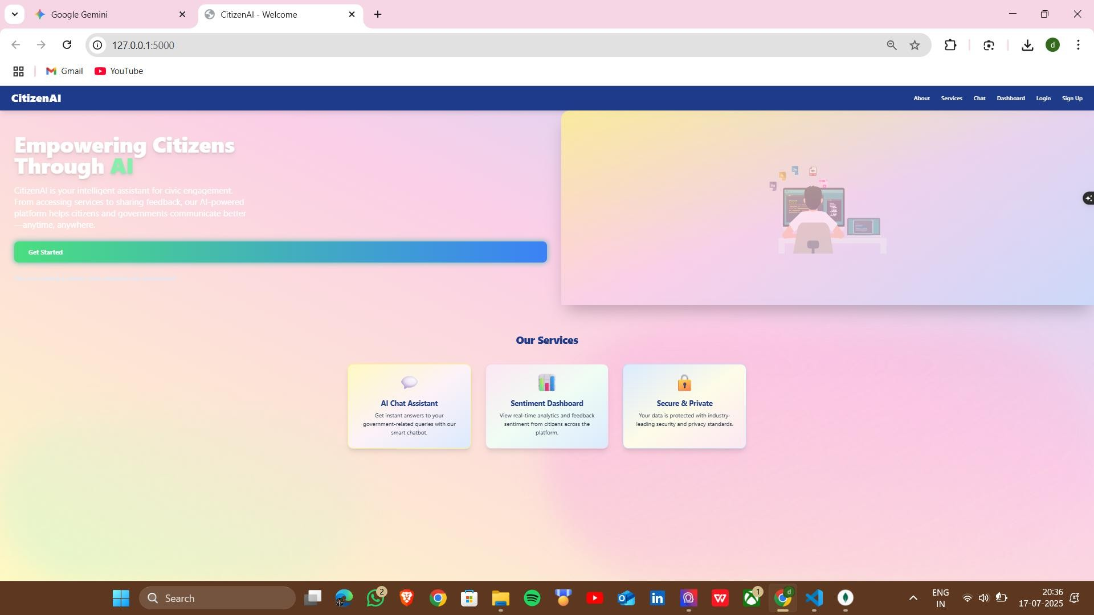

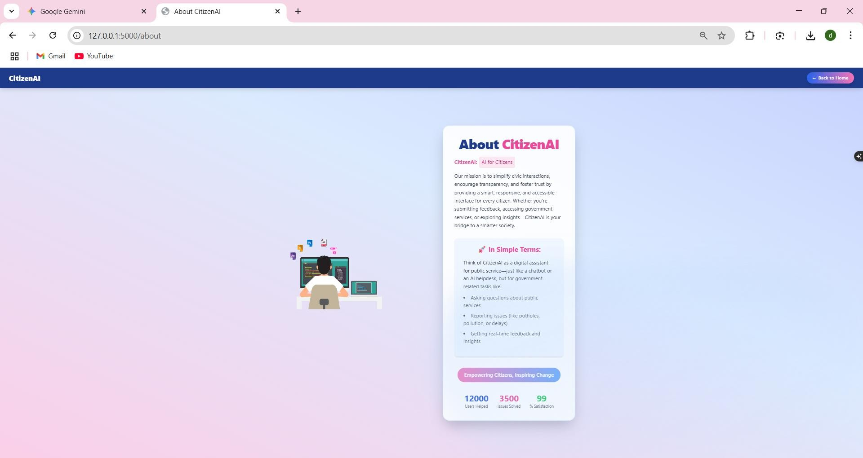

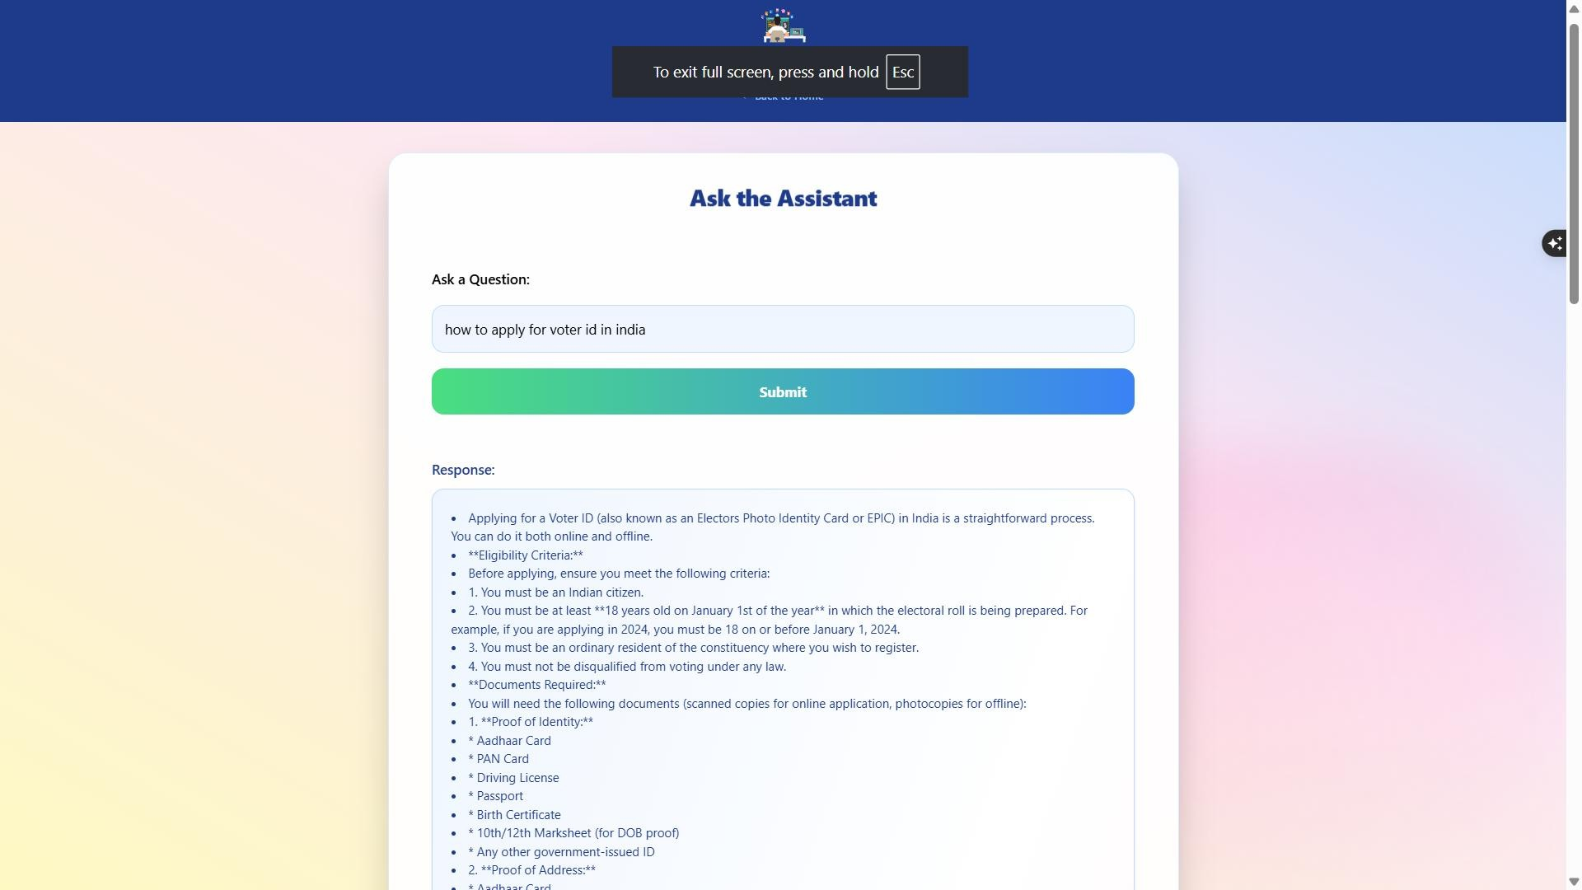

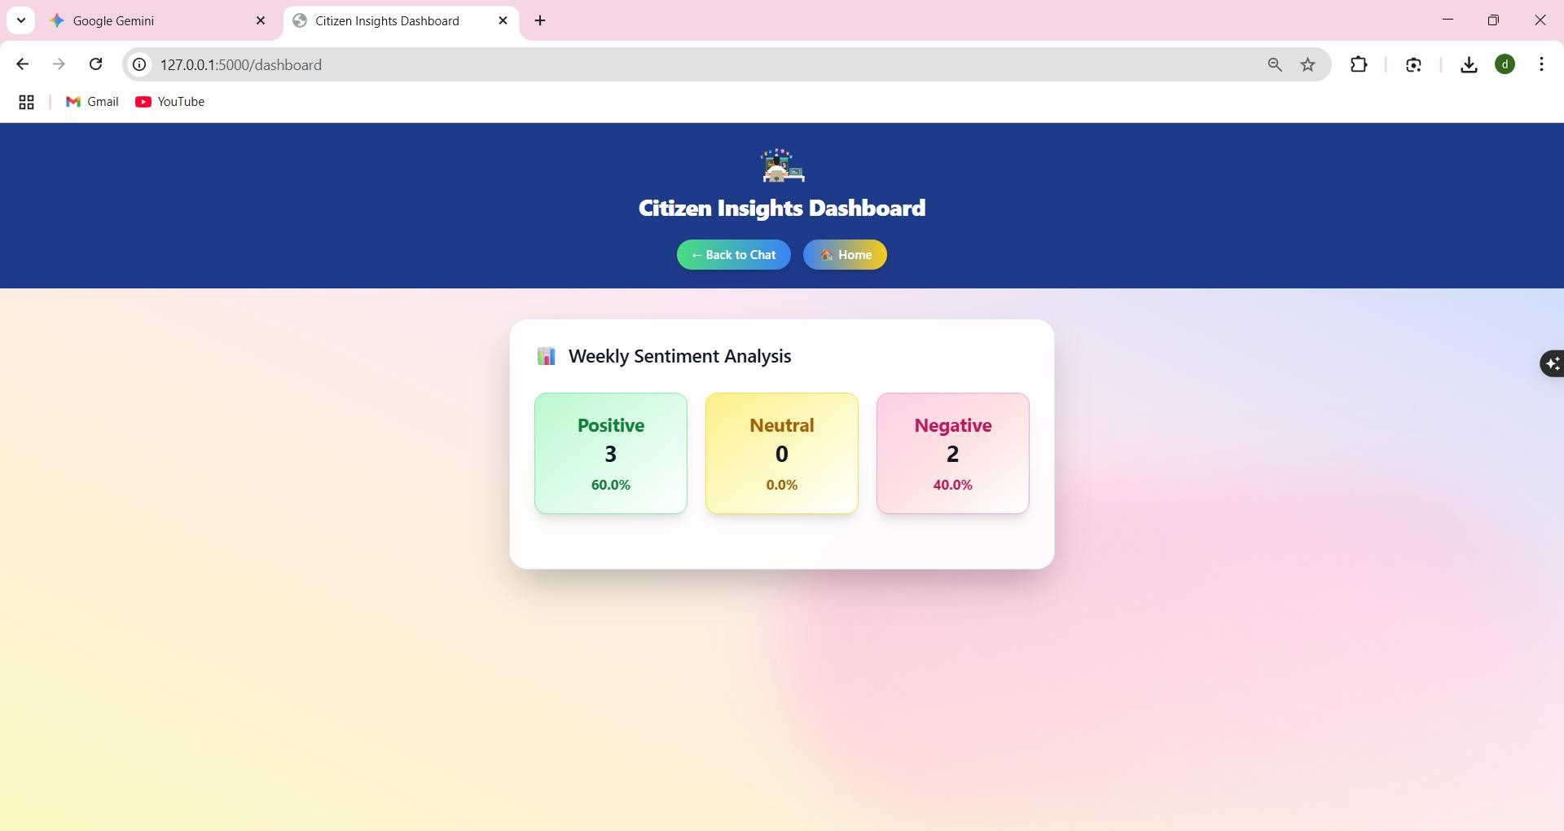

**8. ADVANTAGES & DISADVANTAGES**

# Advantages

* **Real-time, AI-powered responses to citizen queries using IBM Granite models.**
* **Sentiment analysis provides valuable insights into public mood and service feedback.**
* **Role-based access allows both citizens and government officials to use the platform effectively.**
* **Dynamic dashboards support data-driven governance and service improvement.**
* **Modular and cloud-native design enables scalability across cities and departments.**
* **Reduces manual workload and response delays for public-facing departments.**

# Disadvantages

* Requires internet connectivity and digital literacy from citizens.
* Initial deployment and integration with existing government systems may require technical onboarding.
* AI model accuracy may need continuous monitoring and fine-tuning for local context and language nuances.

# 9. CONCLUSION

Citizen AI effectively bridges the gap between citizens and government agencies by offering an intelligent, real-time engagement platform. Through conversational AI, sentiment analytics, and a responsive dashboard, the platform empowers both sides of public interaction. It modernizes communication, enhances transparency, and supports responsive governance. Its modular, scalable architecture positions it well for adoption by local, regional, and national government bodies.

# 10. FUTURE SCOPE

* Multilingual **support** to cater to diverse populations and improve accessibility.
* **Integration with government CRMs and service portals** (e.g., municipal complaint systems, public utility dashboards).
* **Offline data capture and delayed sync** for low-connectivity environments.
* **Voice-based interface** to support accessibility for non-literate users.
* **Machine learning model improvements** for better sentiment understanding and topic classification.
* **Predictive analytics** to anticipate citizen concerns or service bottlenecks before they escalate.

# 11. Project Links & Demo

## GitHub & Project Demo Link

- GitHub: https://github.com/dineshpushadapu/citizen-ai - Demo Video: <https://drive.google.com/file/d/1YxEU3TwG6lRy1nARGIa1qNUzPebvEp_h/view?usp=drive_link>